**Information System Management Lab**

**BCOM 307**

**Assignment #13**

***Submitted by:***

**Name:** YASH JAIN

**Enrollment No:** 03914788818

**Semester:** B.Com(H) 5th Semester

**Class:** B.COM(H)

**Section:** B.Com 5A

**Date of Submission:** 08/10/2021

***Submitted to:***

**Praveen Kumar Singh**

**Assistant Professor, MAIMS**



**Department of Commerce**

**Maharaja Agrasen Institute of Management Studies**

**Affiliated to Guru Gobind Singh Indraprastha University, Delhi**

**Sector -22, Rohini, Delhi -110086, India; www.maims.ac.in**

Maharaja Agrasen Institute of Management Studies

Affiliated to GGS IP University; Recognized u/s 2(f) of UGC Recognized by Bar Council ofIndia; ISO 9001: 2015

Certified Institution Sector 22, Rohini, Delhi -110086, India; [www.maims.ac.in](http://www.maims.ac.in/)

Department of Commerce

Academic Year: 2020-21

Semester: Vth

# Assignment No. 13

# Unit No:

**Course/Subject Code:** BCOM 307 **Subject Title: Information System Management Lab**

# Issue Date Last Date of Submission:

**Instructions for Students:**

# All Questions are Compulsory.

1. The student should attach proper cover page for each assignment clearly mentioning the Assignment No.
2. Each assignment should be prepared by the student individually with proper explaination and screenshots.
3. A4 size ruled sheets should be used for the assignment.
4. Assignment pages should be serially numbered at the bottom of page.

***During online education mode, upload scanned copy of the complete assignment including cover page latest by due date.***

|  |  |  |
| --- | --- | --- |
| **Question No.** | **Question** | **CO No.** |
| 1 | Show the details of clients according to the client name in the ascending order. | **CO1, CO2, CO3, CO4** |
| 2 | Show the details of clients according to the client name in the descending order. |
| 3 | List the Customer Names beginning with the letter 'E'. |
| 4 | List the names of Clients that have 2nd character 'A' in their names. |
| 5 | List the customers whose names have second character 'A' or 'L'. |
| 6 | List the customers whose names begin with the letters 'SM' and it has five letter word. |

**ASSIGNMENT 13 - ‘ORDER BY’ AND ‘LIKE’ CLAUSE**

**Task 1 : Show the details of clients according to the client name in the ascending order.**

This task can be completed using the **‘Order By’** clause. The ORDER BY clause is used to sort the data of a table. It can be used to sort the data in ascending or descending order. The syntax for this is -

Select <columnName> from <tablename> ORDER BY <ColumnName>; (selecting one column)

Select * from <tablename> ORDER BY <columnName>; (selecting all columns)

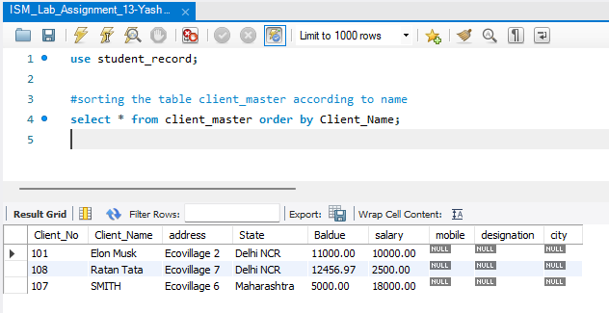

**Task 2: Show the details of clients according to the client name in the descending order.**

This task can be completed using the **‘Order By’** clause, with the **‘desc’** keyword. The DESC keyword sorts the table according to the mentioned column in descending order. This is not required in the case of Ascending order, as the ORDER BY clause sorts the data in ascending order by default. The syntax for this is -

Select <columnName> from <tablename> ORDER BY <ColumnName> desc; (selecting one column)

Select * from <tablename> ORDER BY <columnName> desc; (selecting all columns)

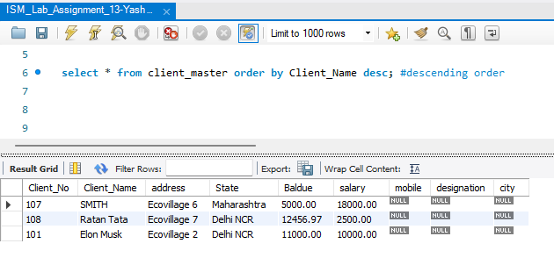

**Task 3: List the Customer Names beginning with the letter 'E'.**

This task can be completed using the **‘like’** keyword. Pattern Matching is used to match specific patterns to find records in our data of the table. It uses the 'LIKE' Operator. The LIKE Operator allows comparison of one string value with other string value. This is achieved using wildcard characters -

1. % : This allows to match any string of any length

2. _ : This allows to match just one single character

The syntax for this is -

Select <columnName> from <tablename> where <columnname> LIKE '(condition)';

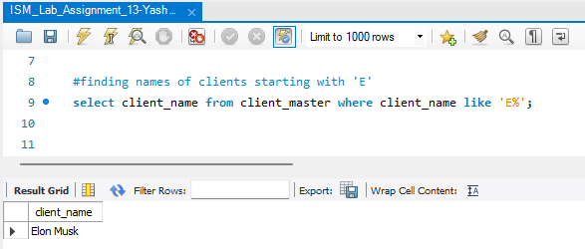

**Task 4: List the names of Clients that have 2nd character 'A' in their names.**

The following task is completed using the **‘like’** command, with the **‘_’** (underscore) and the % (percentage) wild characters.

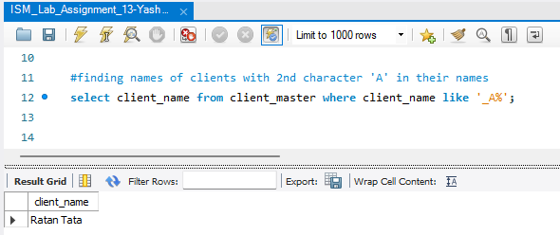

**Task 5: List the customers whose names have second character 'A' or 'L'.**

The following task is completed using the **‘like’** command, with the **‘_’** (underscore) and the % (percentage) wild character, along with the **‘OR’** operator.

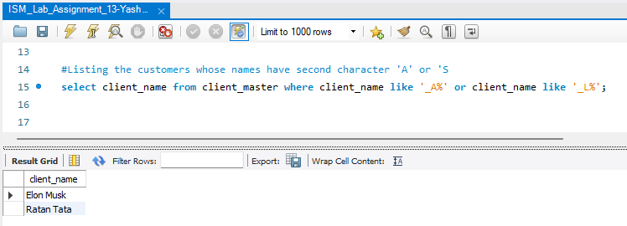

**Task 6: List the customers whose names begin with the letters 'SM' and it has five letter word.**

This task can be completed using the **‘like’** operator, along with the **‘_’** (underscore) wild character.

